### **Week 7 Assignment**

**TOPIC:** **Write an exclusive HTML code to play atleast 10 songs of a common theme, 10 videos of similar size and context and display your assignment report in pdf form in the webpage.**

**Objectives:**

1.**Understanding the <img> Tag (Images in HTML)**

* Learning how to insert images using the <img> tag.
* Understanding attributes like src (image source), width, height, and alt.
* Properly aligning images inside tables for a structured layout.
* Using images to enhance the **visual appeal** of a webpage.

2.**Using the <audio> Tag (Embedding Audio Files in HTML)**

* Learning how to embed audio files in a webpage using the <audio> tag.
* Understanding the controls attribute for play, pause, and volume control.
* Organizing multiple audio files in a table format for proper alignment.
* Ensuring audio elements are **responsive and user-friendly**.

3.**Implementing the <video> Tag (Embedding Videos in HTML)**

* Learning how to embed and display video content using the <video> tag.
* Understanding attributes like controls.
* Structuring videos neatly inside tables to maintain a **clean layout**.
* Making videos **accessible and interactive** for users.

4.**Using the <iframe> Tag (Embedding External Content in HTML)**

* Learning how to embed external content like **PDFs** using <iframe>.
* Understanding attributes like src, height, and width for proper display.
* Using <iframe> to embed an **assignment report** in a structured format.

### **TECHNOLOGY USED:**

**1. HTML Image Tag (<img>)**

* Used to display images on the webpage.
* Attributes used:
  + src → Specifies the image file path.
  + width, height → Adjusts the image size.
  + alt → Provides alternative text for accessibility.
* Applied in **song cover images** and **icons** to enhance the webpage visually.

**2. HTML Audio Tag (<audio>)**

* Used to embed **audio files** directly into the webpage.
* Attributes used:
  + controls → Enables **play, pause, and volume** control.
  + src → Specifies the audio file location.
* Implemented to allow users to **listen to Taylor Swift's songs** interactively.

**3. HTML Video Tag (<video>)**

* Used to embed **video content** in the webpage.
* Attributes used:
  + controls → Provides **play, pause, and fullscreen** options.
  + width, height → Adjusts the video size for proper alignment.
  + src → Defines the video file path.
* Used to organize **educational YouTube-style videos** in a structured format.

**4. HTML Iframe Tag (<iframe>)**

* Used to embed **external content like PDFs and web pages**.
* Attributes used:
  + src → Specifies the file or webpage URL to embed.
  + height, width → Controls the size of the embedded content.
* Implemented to **embed the assignment report (PDF)** directly inside the webpage.

Source Code:

<!DOCTYPE html>

<html>

<head>

<title>Week 7 Assignment</title>

</head>

<body bgcolor="black">

<center>

<br><br>]

<font color="yellow" size="20px" face="cursive"><b>Welcome to My Songs and Videos Collection!</b></font>

<br><br><br><br><br><br><br><br><br><br>

<font color="white" size="20px" face="arial"><b>Taylor Swift's Songs</b></font>

<br><br>

<table cellspacing="20">

<tr align="center">

<td><img src="lovestory.jpeg" width="300px"></td>

<td><img src="youbelongwithme.jpeg" width="300px"></td>

<td><img src="blankspace.png" width="300px"></td>

</tr>

<tr align="center">

<td><audio src="songs/lovestory.mp3" controls></audio></td>

<td><audio src="songs/youbelongwithme.mp3" controls></audio></td>

<td><audio src="songs/blankspace.mp3" controls></audio></td>

</tr>

<tr align="center">

<td><img src="shakeitoff.png" width="300px"></td>

<td><img src="wildestdreams.jpg" width="300px"></td>

<td><img src="alltoowell.jpg" width="300px" height="300px"></td>

</tr>

<tr align="center">

<td><audio src="songs/shakeitoff.mp3" controls></audio></td>

<td><audio src="songs/wildestdreams.mp3" controls></audio></td>

<td><audio src="songs/alltoowell.mp3" controls></audio></td>

</tr>

<tr align="center">

<td><img src="cruelsummer.jpg" width="300px"></td>

<td><img src="antihero.jpeg" width="300px"></td>

<td><img src="thearcher.png" width="300px"></td>

</tr>

<tr align="center">

<td><audio src="songs/cruelsummer.mp3" controls></audio></td>

<td><audio src="songs/antihero.mp3" controls></audio></td>

<td><audio src="songs/thearcher.mp3" controls></audio></td>

</tr>

<tr align="center">

<td></td>

<td><img src="enchanted.png" width="300px"></td>

<td></td>

</tr>

<tr align="center">

<td></td>

<td><audio src="songs/enchanted.mp3" controls></audio></td>

<td></td>

</tr>

</table>

<br><br><br>

<br><br><br>

<br><br><br>

<img src="youtubelogo.webp" width="35px" height="35px">

<font color="white" size="20px" face="arial"><b>YouTube Videos</b></font>

<br><br>

<table cellspacing="20">

<tr align="center">

<td><video src="videos/video1.mp4" controls width="500px"></video></td>

<td><video src="videos/video2.mp4" controls width="500px"></video></td>

</tr>

<tr align="center">

<td><font color="green" size="4px"><b>Explained: 5 Fun Physics Phenomena</b></font></td>

<td><font color="green" size="4px"><b>How An Infinite Hotel Ran Out Of Room</b></font></td>

</tr>

<tr align="center">

<td><video src="videos/video3.mp4" controls width="500px"></video></td>

<td><video src="videos/video4.mp4" controls width="500px"></video></td>

</tr>

<tr align="center">

<td><font color="green" size="4px"><b>How Old Is The Earth?</b></font></td>

<td><font color="green" size="4px"><b>Is This What Quantum Mechanics Looks Like?</b></font></td>

</tr>

<tr align="center">

<td><video src="videos/video5.mp4" controls width="500px"></video></td>

<td><video src="videos/video6.mp4" controls width="500px"></video></td>

</tr>

<tr align="center">

<td><font color="green" size="4px"><b>4 Revolutionary Riddles</b></font></td>

<td><font color="green" size="4px"><b>The Most Controversial Problem in Philosophy</b></font></td>

</tr>

<tr align="center">

<td><video src="videos/video7.mp4" controls width="500px"></video></td>

<td><video src="videos/video8.mp4" controls width="500px"></video></td>

</tr>

<tr align="center">

<td><font color="green" size="4px"><b>This Is the Weirdest Instrument On Earth</b></font></td>

<td><font color="green" size="4px"><b>What Actually Expands In An Expanding Universe?</b></font></td>

</tr>

<tr align="center">

<td><video src="videos/video9.mp4" controls width="500px"></video></td>

<td><video src="videos/video10.mp4" controls width="500px"></video></td>

</tr>

<tr align="center">

<td><font color="green" size="4px"><b>Why Life Seems to Speed Up as We Age</b></font></td>

<td><font color="green" size="4px"><b>World's Roundest Object!</b></font></td>

</tr>

</table>

<br><br><br><br><br><br><br><br><br><br>

<font color="white" size="10px" face="arial"><b>Assignment Report</b></font>

<br><br>

<iframe src="assignment_report.pdf" height="500px" width="1000px"></iframe>

<br><br><br>

<font color="yellow" size="20px" face="cursive"><b>Thank You for Visiting My Website!</b></font> <br>

<font color="yellow" size="20px" face="cursive"><b>Have a Great Day!</b></font>

</center>

</body>

</html>

Output:

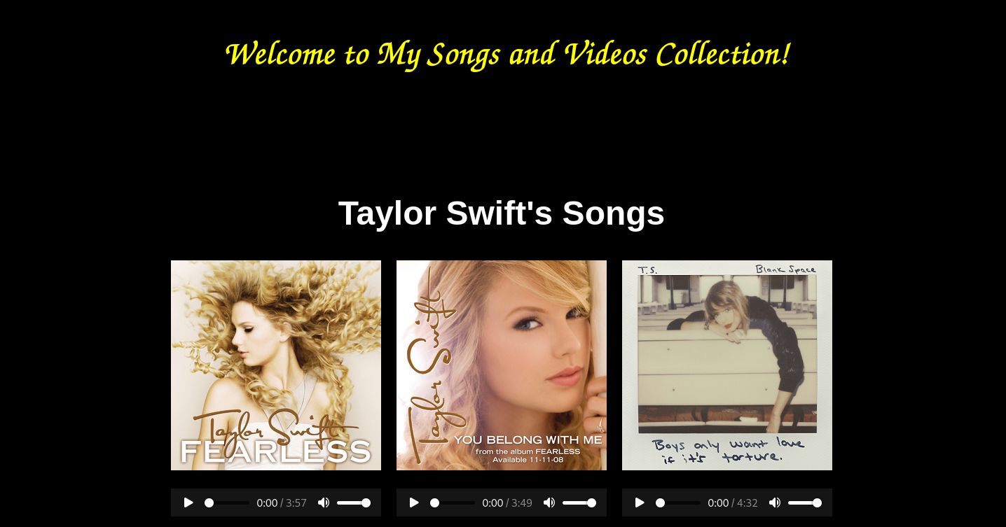

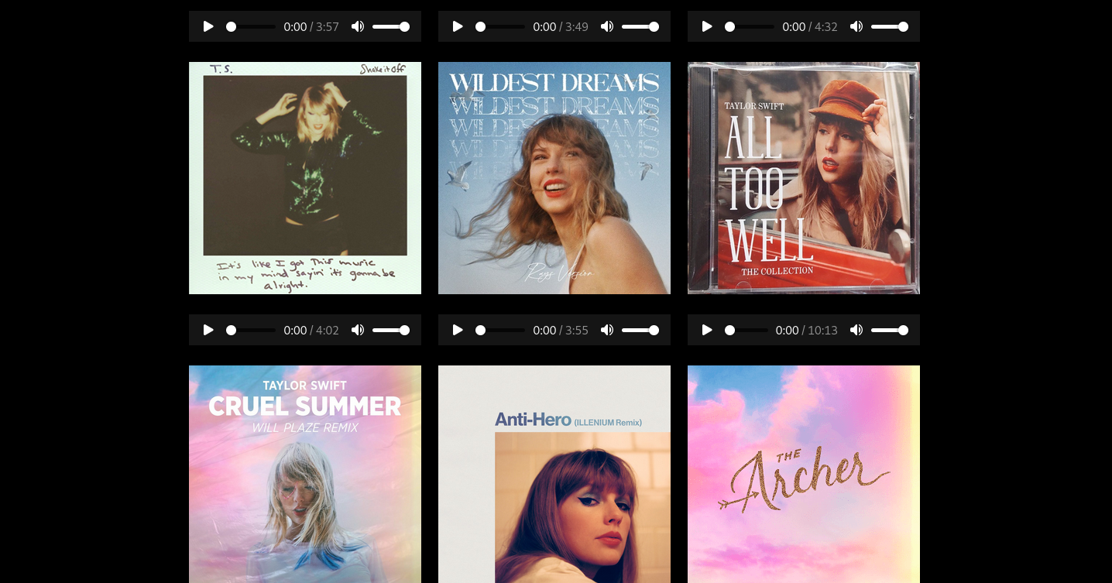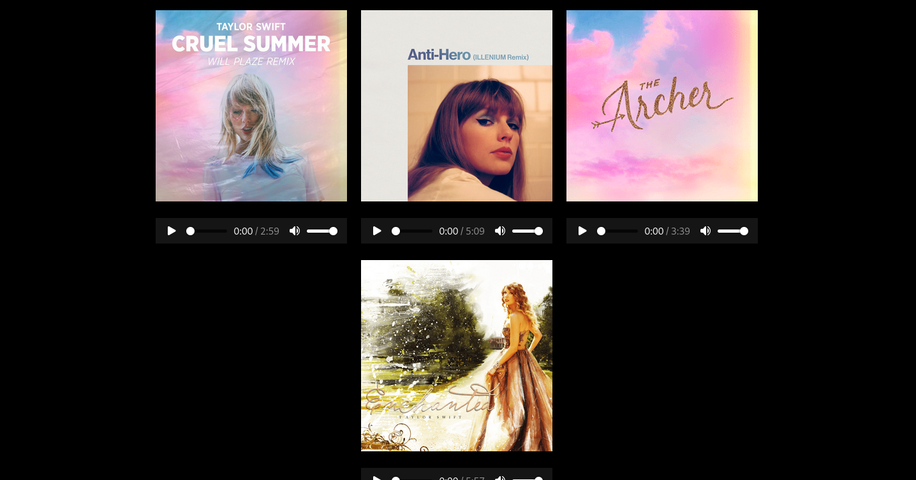

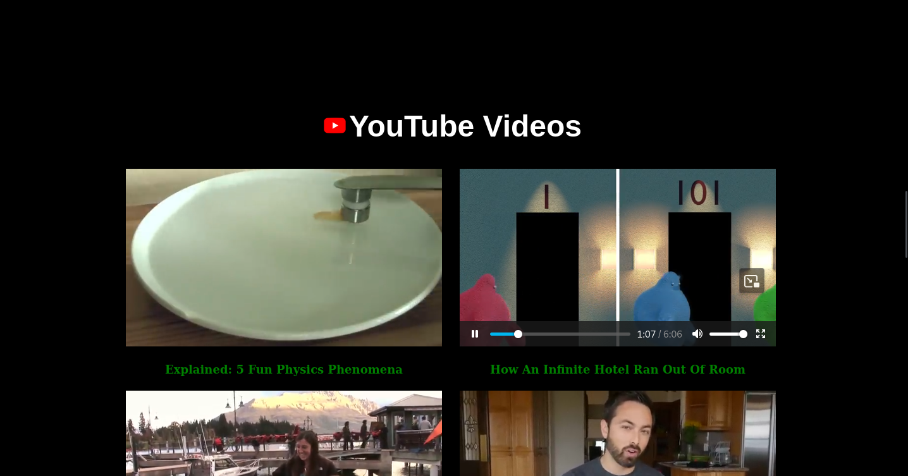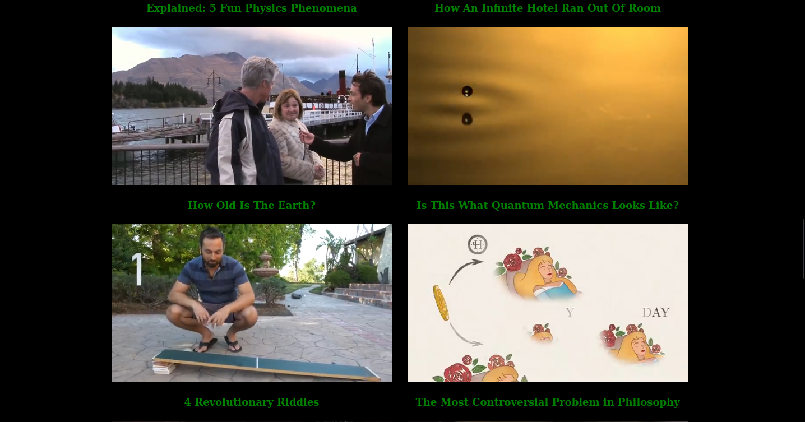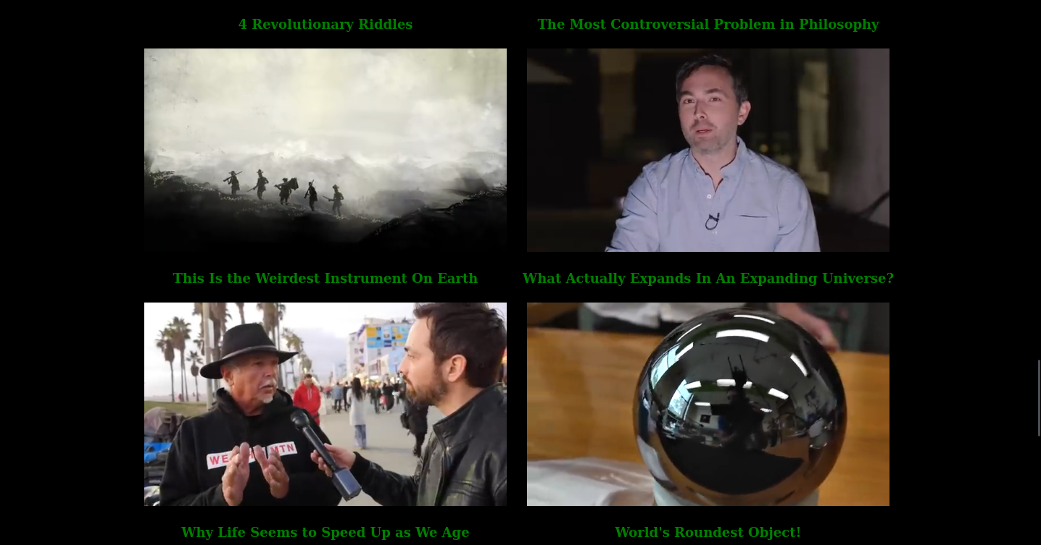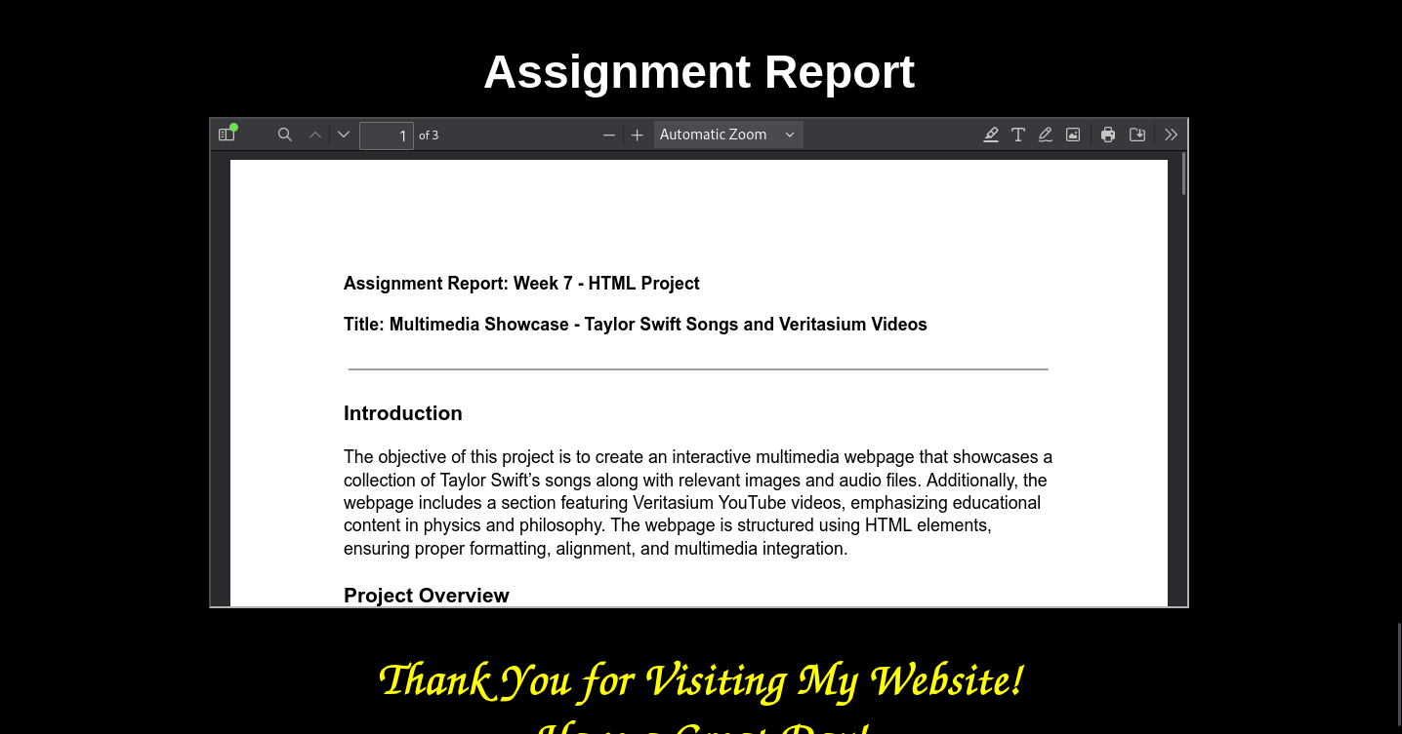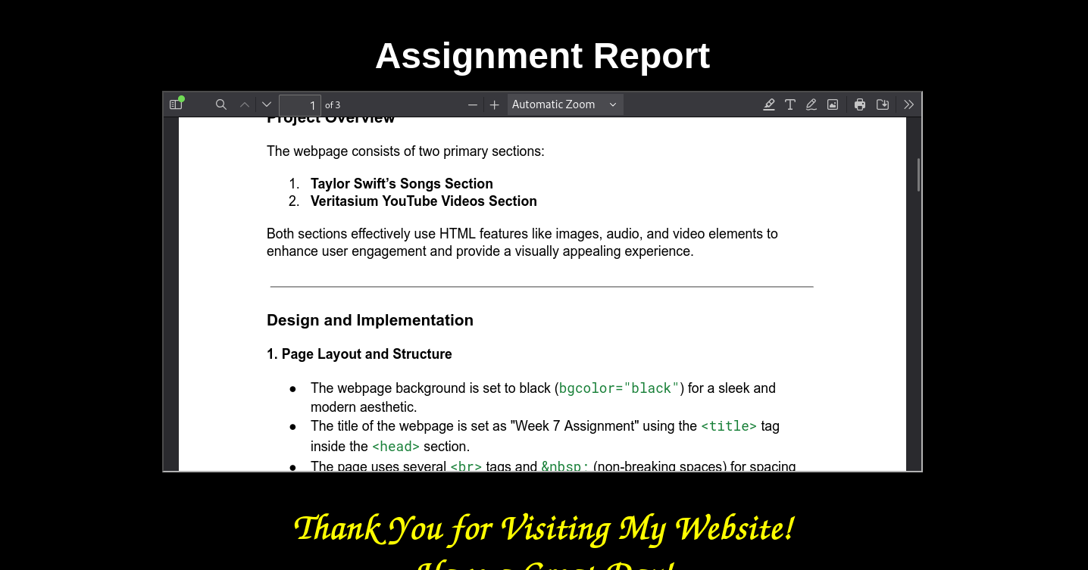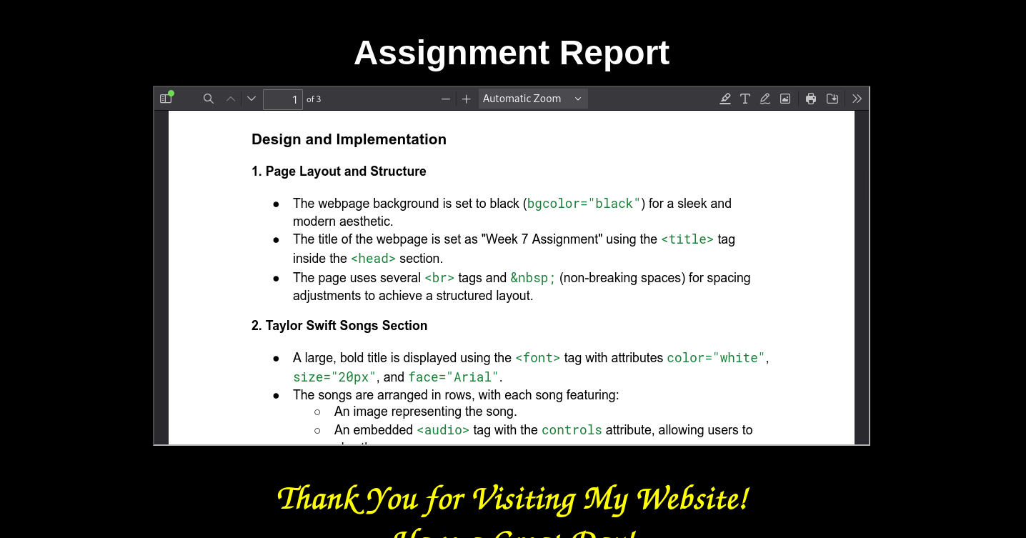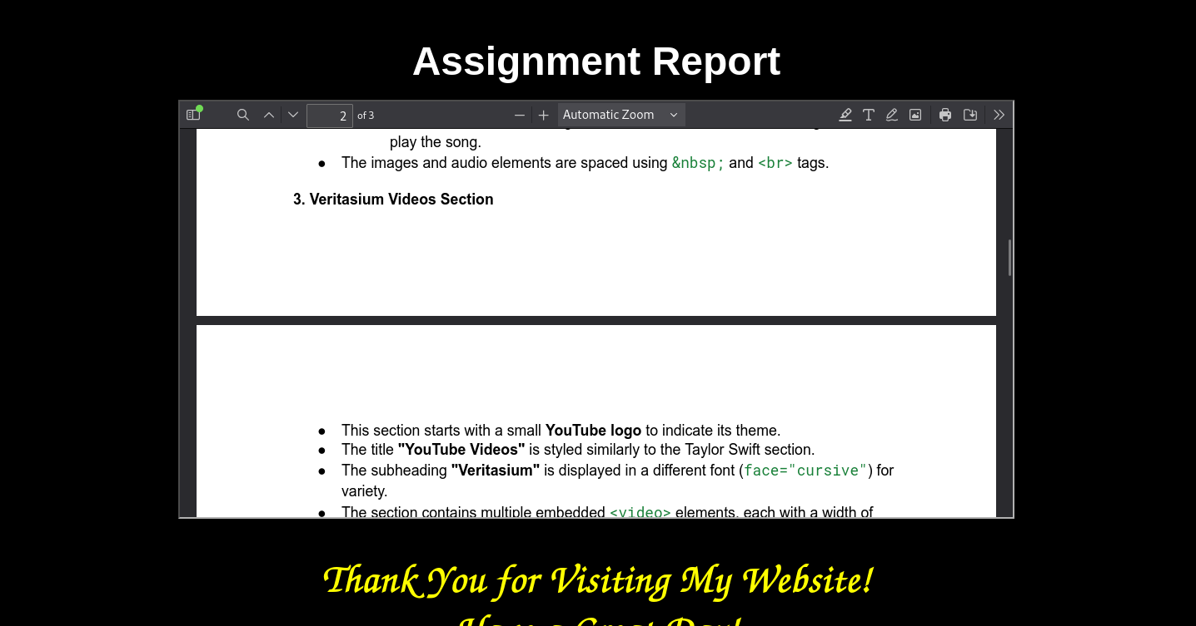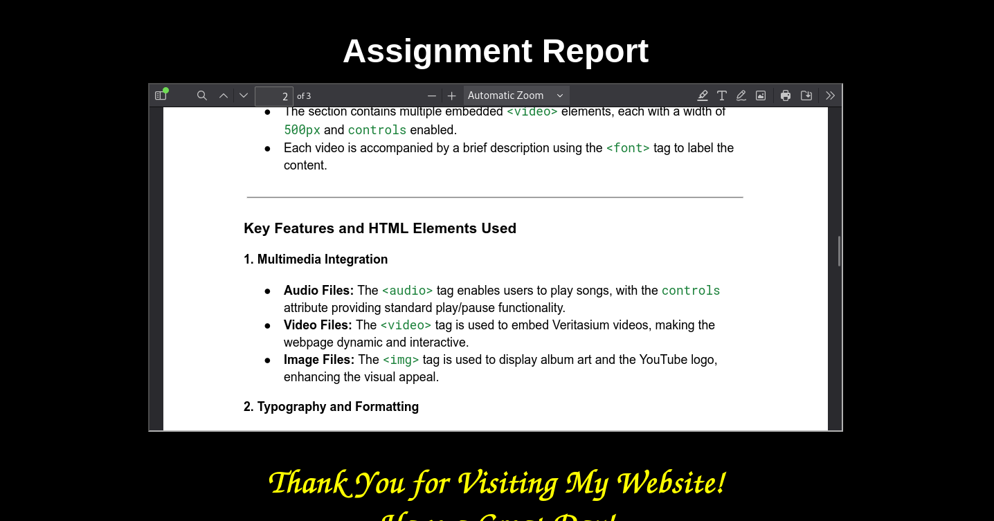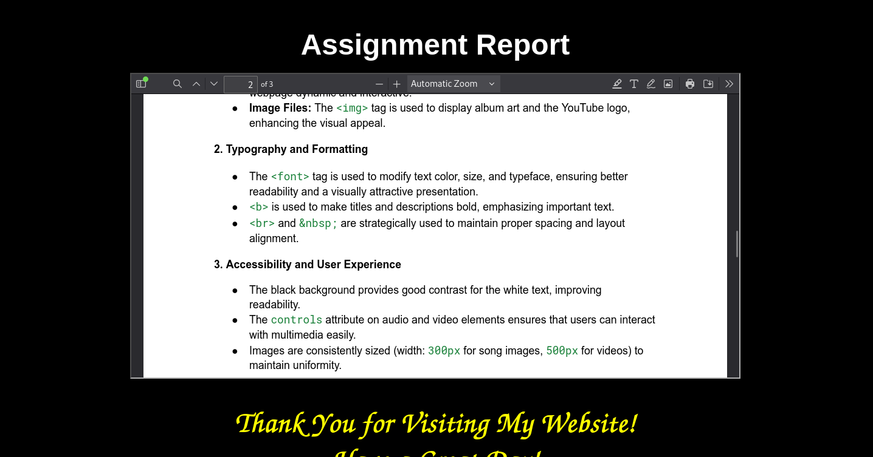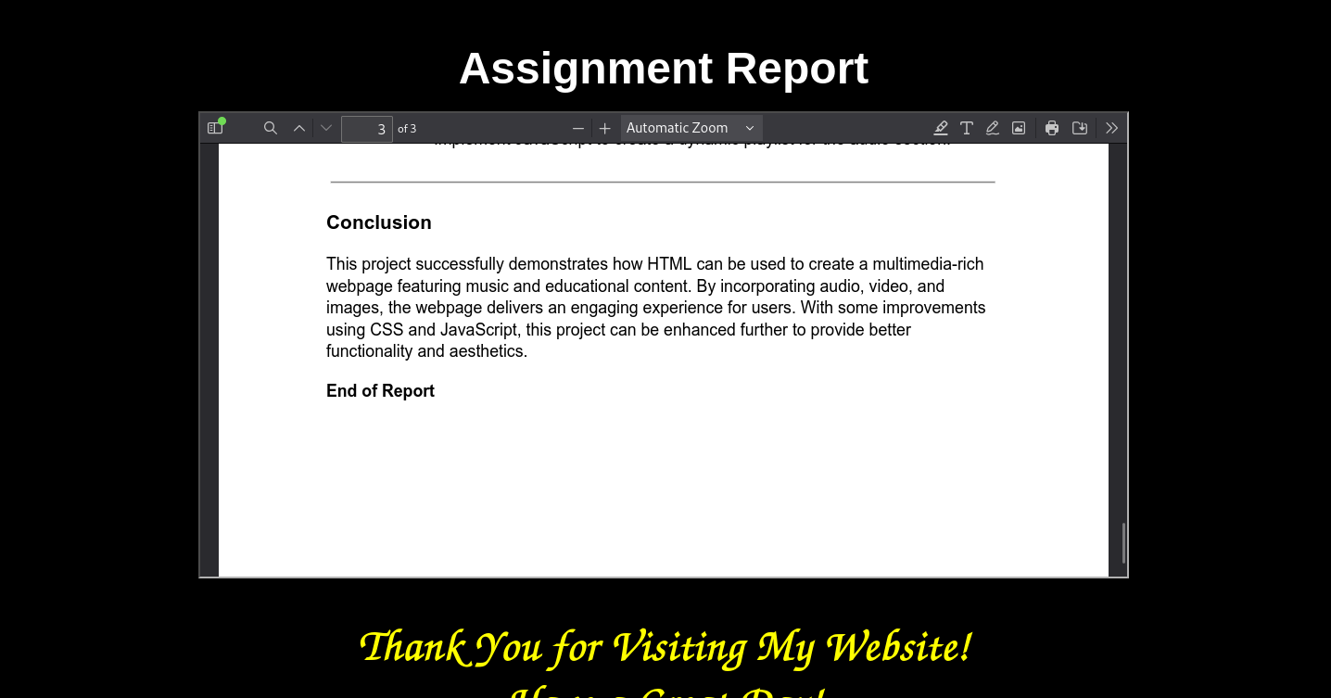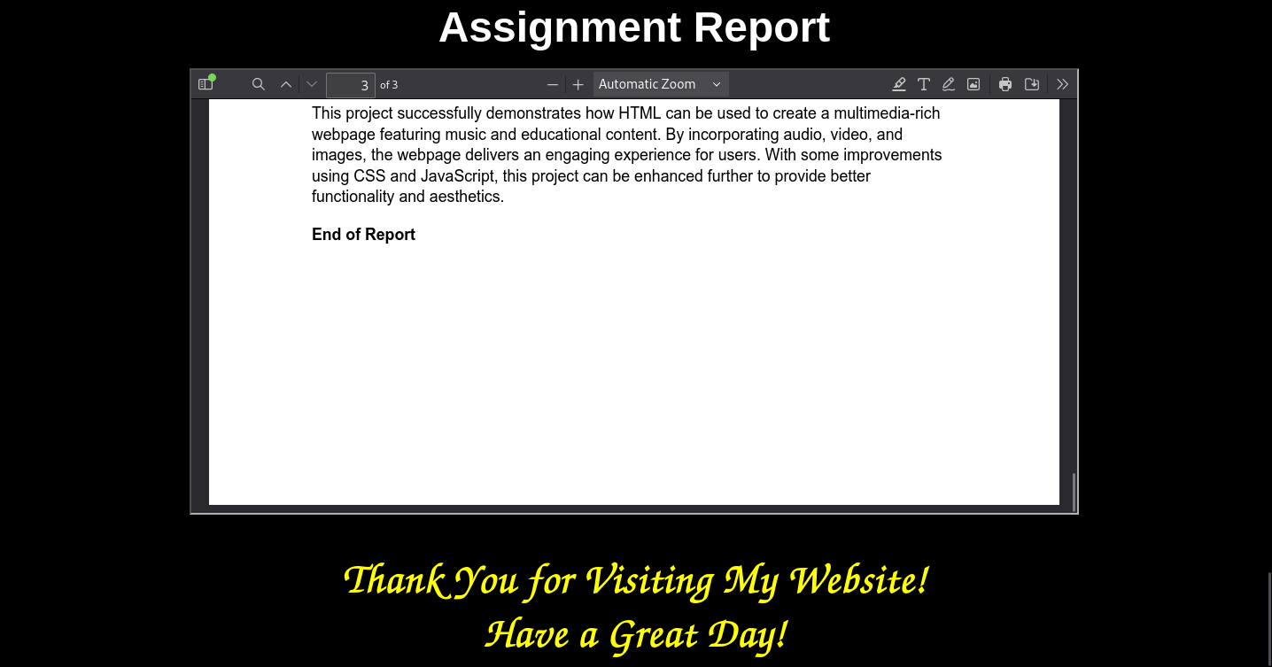

**Submitted by:**

Name : Abhinash Toijam

Roll no. : BC 1953

Sec : A

BCA 4th semester